# Introduction

Your submission should be prepared on an A4 page with 25 mm margins at the top and the bottom, and 20 mm margins on the left and right. Use the Times New Roman font for the entire document.

The top section of the first page of the paper should be used for the title of the paper, list of authors, and author affiliations.

The paper must not exceed 3000 words.

# Paper Sections

## Title, authors, and authors’ affiliations

Titles should be in bold with a font size of 12. Please do not use more than two lines for the title and try to limit it to 10 words.

Authors, authors affiliations, and other information should be of a font size of 12. More than one affiliation of an author should be indicated by numbers, superscripted after the author’s name. Do not number the authors if they are all from the same institution.

You may include author contact details and other information.

## Abstract

The abstract of your paper should be no longer than 100 words. Abstracts must include background on the research area, what are its shortfalls, what methods were utilised, what are the results, and what is the lasting contribution of the submission.

## Body

The body of the paper should contain a/an:

* Introduction
* Simulation and/or experiment
* Discussion and result analysis
* Conclusion

The headings of each section should be of size 12 font and should be capitalised and underlined. The headings of the subsections should be in a bold 10-point-size font. The body text should be font size 10. Neither the sections nor subsections should be numbered.

## Figures and Tables

Figures and Tables are preferably included immediately adjacent to the text referring to them. Both must have a number and caption. Figure captions should be italicised and be of 9 font size. Figure 1 is an example of an image with a caption below the figure. Make sure text elements in figures are easily readable, high-resolution images are preferable.

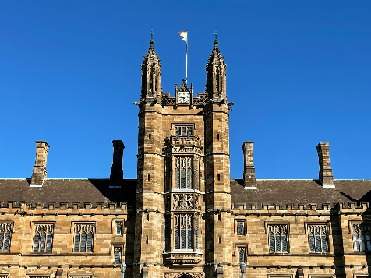

*Figure 1: University of Sydney Quadrangle*

Tables should include borders at the top and bottom of the header row and include a border under the bottom row of the table. Do not include borders on the left and right. They should also have a caption. Table 1 is an example of a table with a caption.  
   
*Table 1: Example*

|  |  |  |
| --- | --- | --- |
| Heading 1 | Heading 2 | Heading 3 |
| Entry 1A | Entry 2A | Entry 3A |
| Entry 1B | Entry 2A | Entry 3B |

## References

Harvard referencing style should be used throughout the submission. All cited publications should be listed alphabetically at the end of the paper.

# Submission instructions

1. Please convert your entire document to PDF format.
2. Papers must be no longer than 3000 words.
3. The file name should consist of the submitter’s full name and the title of the paper separated with a dash (e.g. Submitter’s name – Title of paper).
4. The maximum file size is 10MB.
5. If your submission does not abide by the guidelines, you paper may not be reviewed.
6. Submit your paper here: <https://project-leadership-eng.sydney.edu.au/2026-call-for-papers/>